The Holocaust
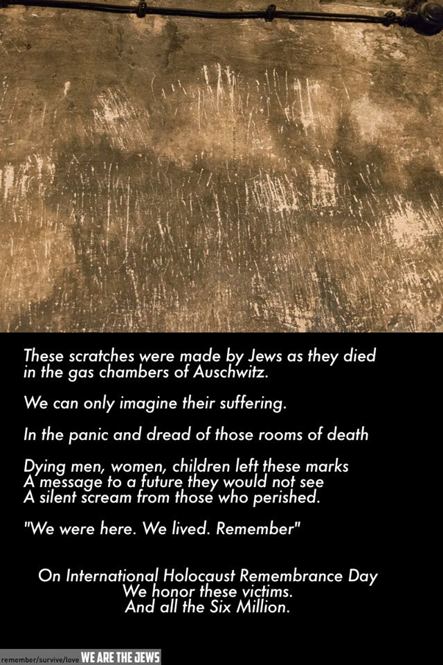
Why teach and learn about the Holocaust when there have been so many other instances of mass suffering of target groups throughout history? Further, why teach and learn about the Holocaust when other crimes against humanity are perpetrated today?
A clear and well-informed understanding of the Holocaust, the paradigmatic genocide, may help educators and students understand other genocides, mass atrocities, and human rights violations. Teaching about mass suffering only began after the Second World War, or, to be specific, after the Holocaust, the attempt by the Nazis and their collaborators to completely destroy European Jewry. In part due to our investigation of the Holocaust, a whole field of genocide studies has developed.
Mass violence, torture, violations of fundamental human rights, and the mistreatment of human beings is not a new aspect of humanity; documentation of such events spans the historical record. It is imperative that a greater understanding of the psychological, cultural, political, and societal roots of human cruelty, mass violence, and genocide be developed. We need to continue to examine the factors which enable individuals collectively and individually to perpetrate evil/genocide and the impact of apathetic bystanders as fuel for human violence. While an exact predictive model for mass violence/human cruelty is beyond the scope of human capability, we have an obligation to develop a model that highlights the warning signs and predisposing factors for human violence and genocide. With such information, we can develop policies, strategies, and programs designed to counteract these atrocities.
Why relate or compare the Holocaust to other genocides, crimes against humanity and mass atrocities?
- In comparing the Holocaust to other genocides and crimes against humanity it should be possible to sharpen understandings not only of similarities between events but also of key differences. In so doing, it may be an opportunity to better understand the particular historical significance of the Holocaust, and how study of the Holocaust might contribute to our understanding of other genocidal events. By the same token, learning about other genocides may contribute to deeper understandings about the Holocaust.
- In comparing the Holocaust to other genocides and crimes against humanity it may be possible to identify common patterns and processes in the development of genocidal situations. Through the understanding of a genocidal process and in identifying stages and warning signs in this process, a contribution can hopefully be made to prevent future genocides.
- To compare the Holocaust to other genocides may be a means to alert young people to the potential danger for other genocides and crimes against humanity to evolve today. This may strengthen an awareness of their own roles and responsibilities in the global community.
- To compare the Holocaust to other genocides may help to overcome the lack of recognition of other genocides.
- Knowledge of the Holocaust may also be helpful in considering how to come to terms with the past in other societies after genocide, how communities can respond to genocide, and how survivors can attempt to live with their experiences.
In popular discourse, from media debates to everyday discussions, a number of terms relating to mass atrocities – crimes against humanity, war crimes, genocide and Holocaust – are frequently used interchangeably, sometimes giving the impression that they have the same meaning. Although these terms are often mentioned in the same context and, indeed, can be related, they each have very distinct and specific meanings.
Crimes against humanity are widespread or systematic attacks on the civilian population, irrespective of whether the people are nationals or non-nationals and irrespective of whether the attacks are committed in time of war or in time of peace. The attacks can for instance constitute murder, extermination, forced displacement, slavery, rape, torture and other inhumane acts. Crimes against humanity are essentially about the violation of common human rights and values. It is also the umbrella category under which war crimes? and genocide? both fall in international law.
War crimes are criminal acts committed during armed conflicts and the term refers to grave breaches of the rules of warfare. These rules are set down in a number of international agreements, first and foremost the Geneva Conventions. These rules of warfare are intended to protect civilians, women, children, prisoners of war and sick or wounded military personal during armed conflicts. Acts such as torture, destruction of property, and the killing of civilians or hostages can be defined as war crimes, as can the wanton destruction of cities, towns and villages, or any devastation not justified by military necessity. War crimes are committed as part of a larger political or military campaign.
Genocide refers to the coordinated and planned destruction of a group. While genocide is almost always accompanied by mass killing, this crime is an attempt to destroy the group, not necessarily to murder every member of that group. Some call genocide ‘the crime of crimes’. Others label genocide as the ultimate crime against humanity because the aim of genocide is to eradicate a part of humanity.
The international legal definition of the crime of genocide
(a) Killing members of the group;
(b) Causing serious bodily or mental harm to members of the group;
(c) Deliberately inflicting on the group conditions of life calculated to bring about its physical destruction in whole or in part;
(d) Imposing measures intended to prevent births within the group;
(e) Forcibly transferring children of the group to another group.
The Holocaust is often called the paradigmatic genocide. In a number of ways, the Holocaust functions as a benchmark for other genocides. Some reasons for this are:
- the term genocide? did not exist before the Holocaust, but was coined in 1943-4 by the Polish Jewish lawyer Raphael Lemkin in response to the Nazi crimes
- the Holocaust was an extreme form of genocide in which the perpetrators sought to destroy a human group through the attempted murder of every member of that group
- the Holocaust is well documented, researched and published
- the Holocaust is considered a watershed event in world history
- the impact of the Holocaust to our present Western society is immense as it took place in the heart of Europe
- its strong place in our collective memory means that other genocides are often seen and interpreted through the lens of our understanding about the Holocaust
How do these terms relate to each other?
In international law, crimes against humanity can be seen as an umbrella category of international crimes. The following fall under this category:
Genocide
War crimes
Aggression
Genocide differs from other crimes against humanity by the intention to completely or partly destroy a certain group of people. Other crimes against humanity do not require this specific intent to destroy a group.
Some crimes against humanity – such as the use of forced labour, the mass killing of civilians, the confiscation of property and deportation – may be a prelude to genocide or part of its execution. However, these crimes against humanity do not always lead to genocide, nor are they all always a part of genocide.
The Holocaust is the name given to one specific case of genocide: the attempt by the Nazis and their collaborators to destroy the Jewish people. Other genocides committed by the Nazis during the Second World War were the genocides of Poles and of Roma. All were attempts to destroy a group of people, and all were accompanied by mass murder. However, the genocide of the Jewish people was unprecedented in its totality.
We should consider this history from the perspectives of the:
- Victims
- Perpetrators
- Collaborators
- Bystanders
- Rescuers

